Flow Name: New Client Update – Slack to BA/QA Summary

Problem:
New client onboarding details are shared in the Slack channel new-client-invoice-update, but the BA and QA teams are not automatically informed of the key client information required to prepare onboarding artifacts such as cheat sheets. This creates delays and requires manual follow-ups to extract and forward relevant details.

Solution:
This automation monitors structured new client update messages in Slack, extracts key onboarding fields, and automatically posts a summarized notification to the BA/QA Slack channel to initiate cheat sheet creation.
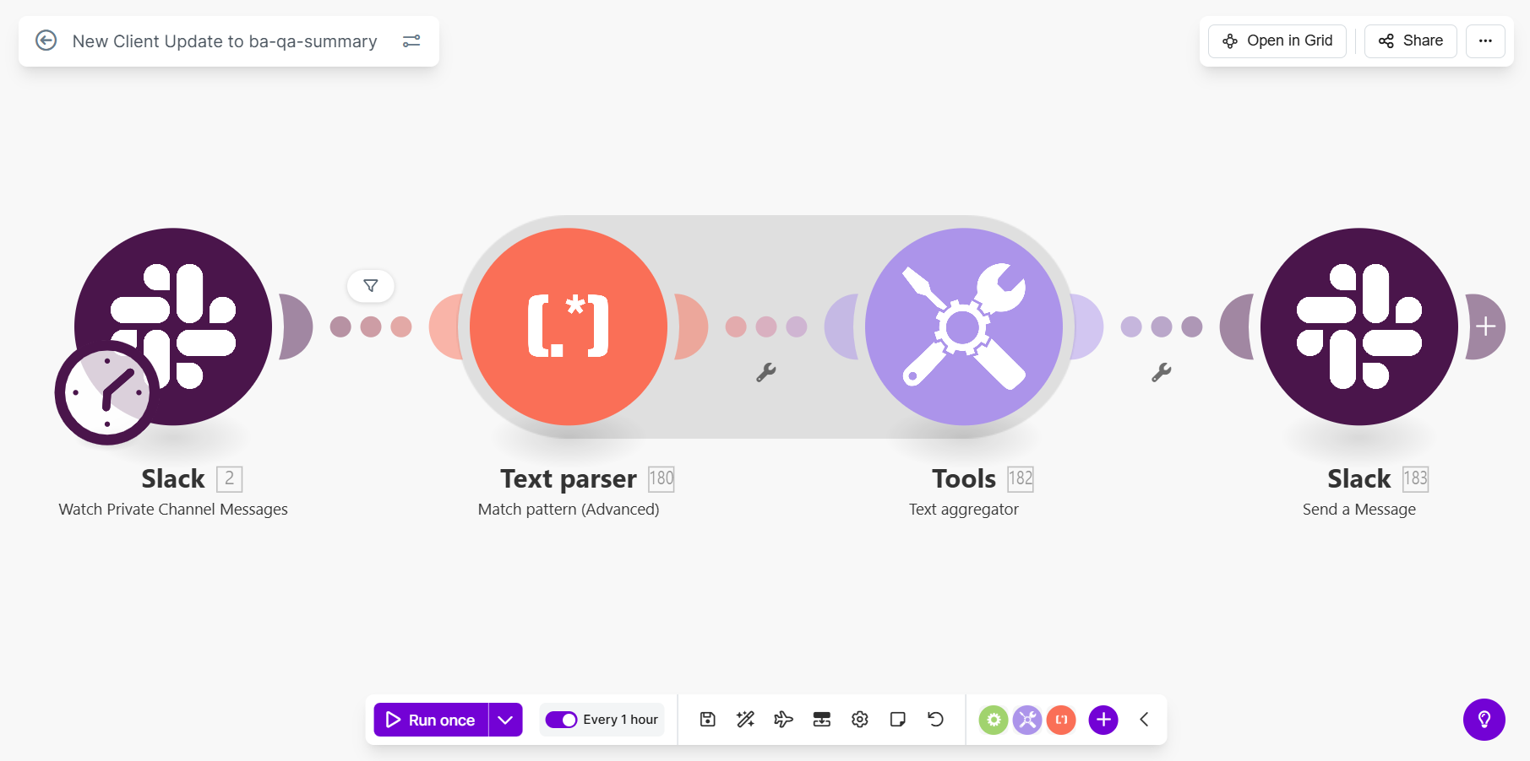
Flow Details:
Step 1: Trigger – Monitor New Client Update Slack Channel
The automation continuously monitors the private Slack channel new-client-invoice-update using the Watch Group Messages module. Pagination is enabled to ensure no messages are missed, and the full message text is captured for downstream parsing.
Step 2: Filter for New Client Update Messages
A conditional check ensures that only messages containing the identifier “New Client UPDATE:” are processed. Messages that do not match this pattern are ignored, preventing unrelated Slack activity from triggering the flow.
Step 3: Extract Key Client Fields from Message
A multiline advanced regular-expression parser scans the Slack message and extracts only the relevant fields required by the BA and QA teams. These fields include:
- Name on Invoices
- Client Name
- Start Date
- CSM
The parser enforces structured message formatting and ensures only deterministic data is extracted.
Step 4: Aggregate Extracted Fields into Summary Text
All extracted fields are aggregated into a single formatted text block using a text aggregator. Each field appears on a new line, preserving readability and context for downstream communication.
Step 5: Post Summary Message to BA/QA Slack Channel
The automation posts a formatted Slack message in the private channel ba-qa-summary-m-u-o-a.
The message:
- Mentions the relevant BA and QA stakeholders
- Clearly indicates that a cheat sheet needs to be created
- Includes the aggregated client details extracted from the original Slack message
Markdown formatting is enabled to improve clarity and readability.

Overall Flow Summary:
This automation ensures that BA and QA teams are immediately notified when a new client is onboarded. By filtering only valid new client update messages, extracting structured client details, and posting a clean summary to the appropriate Slack channel, the flow eliminates manual forwarding, reduces onboarding delays, and ensures downstream teams receive accurate information at the right time.

